Important Question

1. Define Voltage, current, power and Energy.
2. Write the difference between circuit and network.
3. Classify Electrical Circuit Elements.
4. Write the relation between Voltages – Current of Passive Elements.
5. Write the differences between practical voltage and current sources.
6. Classify dependent sources with symbols.
7. Define Kirchhoff’s Voltage Law (KVL) and Kirchhoff’s Current Law (KCL).
8. Calculate voltage V1 for the given circuit using KVL.

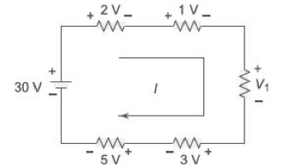

1. Calculate Voltage across A and B for the given circuit using voltage division formula.

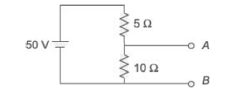

1. Calculate current I3 for the given circuit using KCL.

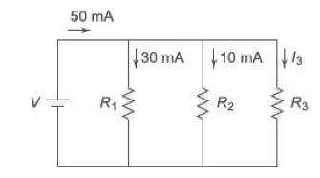

1. Determine the equivalent resistance between A and B for the given circuit.

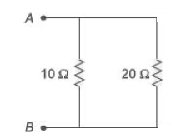

1. 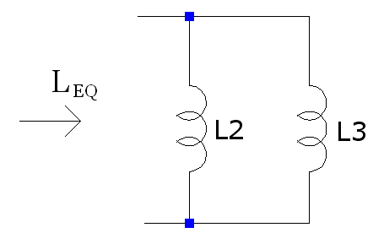
2. 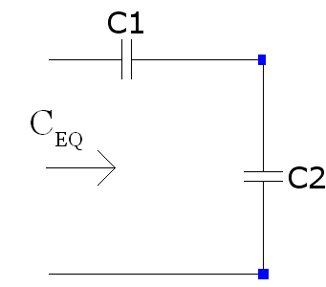
3. Convert the given delta into equivalent star.

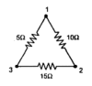

1. Convert the given star (R1=10Ω, R2=20Ω and R3=30Ω) into equivalent delta.

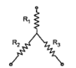

1. Tutorial problems